Centerville
Junior High School
December 2022/January 2023
Newsletter
CENTERVILLE MISSION STATEMENT
To ensure that each student holds the skills needed to strategically problem solve and is prepared to contribute and thrive in the 21st century work force. Each student will demonstrate mastery of common core standards through on-going, authentic and varying assessments. We will ensure this by means of real-world application and through a multi-faceted system of support.

December 2, 2022

As we near the end of the semester and the New Year, this time of year tends to lend itself well to reflecting on the past year. From those nervous first few days when school started to where we are today, it is clear we have all come a long way.
Although the semester ends Thursday, December 22, grade reports will be coming out on January 20, 2023. As we are moving into the New Year, this is a great time to review your child’s first semester progress and help your child set goals for the second semester. The goals should stretch the student but still be realistic and attainable. Goals provide an anchor for students in rough seas and high winds. Take a few moments to establish goals with your child as you review the student progress. If this is something that you might need assistance with, feel free to reach out to your child’s counselor.
During second semester, most student schedules should remain the same. Some schedules will be changing based on the academic needs of our students. New student schedules will be sent home with students on December 12th. These will also be available through the parent and student portal. Students requesting a different elective or other scheduling changes will find a link to the Schedule Change Request Form on the draft schedule. The link must be filled in by Sunday, December 18, 2022. This will provide our staff with enough time to make any needed schedule changes.
I’d like to take a moment to thank our PTSA. This year our PTSA has provided an exceptional amount of support in so many ways. The PTSA hosted the first dance, and quite frankly it was a very successful dance. Our PTSA also provides grants and support for all of our school events. If you are a member of the PTSA, thanks for your support, if you are not a member please consider joining our PTSA and continuing the support appreciated by the teachers, staff and students. PTSA Membership Site
Centerville is preparing to convert from a Junior High School to a Middle School in the 2023-24 school year. Many of you may have questions regarding what this means for next year as we welcome sixth graders and our new seventh graders. We have a PTSA Meeting on Wednesday, January 8th, 2023. Staff members will be presenting at this meeting on construction updates, numbers of new students and teachers, new facilities, and what we will be doing to welcome our newest Mustang students and staff. More specific information regarding the time and locations will be coming soon.
I wanted to share my gratitude to each of you for sending your best and brightest to us each day. I appreciate that each of you are an essential part of the Centerville team in helping your child to be successful. Centerville Mustangs are truly the best!
Have a restful winter break, and I look forward to seeing everyone in the new year.
Sincerely,
Walt Lewis, Proud Principal
Centerville Junior High School

FROM THE DESK OF THE ASSISTANT PRINCIPAL

The winter season is right around the corner. We are already half way through the new school year, with the semester ending on December 22nd. The holiday season has approached and colder weather and rain are upon us. Please make sure to keep yourself healthy by dressing warmly and following all safety protocols. While cases of COVID are not nearly at the same level as last year at this time, we still need to follow all recommended safety precautions to keep all safe and healthy. If your student is experiencing any Covid like symptoms, please follow the district guidelines. Here is the link for your convenience: Covid Parents Chart
Winter and the end of the semester also means report cards will be completed. Grades will be available after January 21st, 2023.They will be available in the Infinite Campus (IC) Parent Portal. Congratulations to the students who earned excellent grades. If your student’s grades are not what they wanted to earn, there are many supports in place to ensure student success at Centerville. Please encourage your students to reach out to their teachers, during class or flextime, for extra support, and to contact their counselors if social/emotional support is needed. If you are having difficulties accessing IC, please contact our front office. We would be happy to help you.
It appears our Mustang community has adjusted to being back to in person learning. I encourage parents to review school rules with your student. Our school wide rules and discipline can be found in the Homework Assignment Book (HAB). All students were given a HAB at the beginning of the school year. Please remind your student that the Centerville Behavior Matrix is posted throughout the campus and the three R’s (Respect, Responsibility, Ready to Learn) lists the behavioral expectations for all of our students. Following the school rules allows all students to learn and feel safe.
This is also a good time to review Centerville’s dress code. Students should not have midriffs showing and pajama pants are not allowed to be worn to school. The complete dress code expectations can be found on page 10 of the HAB. Also, a friendly reminder that there are no cell phones allowed during the school day from bell to bell. In the event that your student is caught on their phone, please refer to the HAB, for the progression of consequences, on page 9. Please remind your student that they can make a phone call from the office if needed. You can also call the office and we can get a message to your student if needed.
While the holiday season may look and feel normal as we are used to, it is very important to remember some are still struggling. We must be grateful for what we have and give back to our community when able. I hope you get to spend some time with your loved ones over the break, and enjoy some R&R (rest and relaxation). I know that is what I am looking forward to the most.
Wishing you all the best,
Mrs. Grimmer
Assistant Principal

December
9 Winter Dance, 7 – 9
22 Early Dismissal, 11:56
22 1st Semester Ends
23 Staff Dev. Day, No School
26-31 Winter Break

January
3-8 Winter Break
9 Classes Resumes, Early Dismissal, 11:56
13 Early Dismissal, 11:56
16 Holiday (M.L. King’s B’Day)
18 PTSA Meeting, 6:30

YEARBOOKS
You can now order a yearbook at https://buytheyearbook.pictavo.com/ (school code is 710356). With the early bird discount, the cost is $30. After December 31, the price will go up to $35.

WINTER DANCE

The winter dance will be held on Friday, December 9, from 7-9 PM. Tickets will be on sale at lunch starting Monday, December 5 and go through the 8th and will cost $8. Tickets will ONLY be sold during this time. Tickets are never sold on the day of the dance.
Replacement IDs can be purchased in the office for $5. Reminder – IDs are never sold on the day of the dance.
In order to participate in an after
school/evening activity, students must be in attendance that school day by 2nd period and remain for the duration of the school day. Medical notes will excuse a tardy or early dismissal so the student may participate.
Students are expected to behave and dance
appropriately. Students may be restricted from
attending subsequent dances for failure to follow these rules. Parents will be contacted to pick up their student for inappropriate dancing.
Students may receive disciplinary actions for
sexual harassment in regards to inappropriate
dancing. All students must be neatly and
appropriately dressed.
PTSA will sell refreshments at the dances. Also, parents are welcome to chaperone school dances. Please click on the sign up genius if you are interested in volunteering or donating food.
https://www.signupgenius.com/go/4090848AAAC2DA5F49-centerville4

TURKEY TROT

To help celebrate Thanksgiving, Merit Club will be running the annual Turkey Trot on December 20th during lunch. All students are invited to join in on the fun! You might seem some teachers out there as well! Signups are ongoing during lunch time in F106. The cost is $1. There are lots of prizes to be handed out.
CANNED FOOD DRIVE EXTENDED
Merit Clubs canned food drive has been extended till December 13th. Help your 1st period class reach their goal and win a prize. All donations go directly to our local food back at Tri-City Volunteers.
Student of the Quarter
Our faculty and staff want to honor students that are the embodiment of what it means to be a Mustang. Someone that perseveres, works hard, and has strong character traits.
This year Centerville Faculty and Staff will be implementing a Student of the Quarter Award. At the end 1st, 2nd, and 3rd quarter we will be implementing this award. For each of our first three quarters, each teacher may submit one name as their Student of the Quarter. Teachers have agreed on the following criteria for choosing the "Student of the Quarter":
- Students exhibiting excellent character traits (Planning and Decision Making, Honesty, Integrity, Responsibility, Citizenship, Respect for Others, Caring, Problem Solving)
- Students that have significantly improved (academically, socially/emotionally, behaviorally)
- Students who have excellent academics, excellent behavior, or excellent participation in class.
Students nominated will receive a certificate and a bumper sticker designating them as a Student of the Quarter. Students will also be invited to a ceremony during Flextime time with the Principal, Assistant Principal, and counselor to present the award.
Each teacher decides which student will receive the award. Students and/or parents should not lobby teachers for an award. Please feel free to ask Principal Lewis or Assistant Principal Grimmer if you should have any questions.

MEDICAL AND DENTAL
APPOINTMENT/ABSENCES
Please send your student to the office in the morning before the start of school with a note indicating the reason and the time he or she needs to be picked up.
The student will receive a pass that allows him or her to leave class and meet you in the office where an adult will need to sign them out. This saves time (especially if the student is in PE and needs to change clothes) and also minimizes interruptions to the classrooms (which is naturally our highest priority).
If it’s a last minute arrangement, even a call ahead to the office will assure that we can send a pass out to the classroom with a minimum of disruption.
Adults do need to sign students out in the office when leaving but when a student returns from an appointment, the adult does not need to sign them in. The student does, however, need to come to the office to get a pass so they can return to class.

FORGOTTEN ITEMS
Lunches and forgotten items may be dropped off at the office. Unfortunately, we cannot interrupt instructional time by delivering messages/items to students. The student must check in the office at lunch.
For safety reasons, students may not enter the parking lot or pick things up from a car directly. Please arrange to meet your child in front of the office.

STUDENT MEALS
FREE Student Meals 2021-2022
All FUSD student meals will be FREE for the school year 2021-2022.
Lunch, breakfast, and second chance/recess breakfast (at the school sites with a breakfast program) will be free for all on-campus FUSD students 2 to 18 years old. Students do not need to meet any eligibility standards to receive meals at no cost.
Because meals are free there will be NO Free and Reduced Price Meal Application to fill out this school year 2021-2022.
For special dietary needs please visit fremont.k12.ca.us, search Health Forms/Medication, under allergy management there is a special meal form (03a).
Please let us know what you think! Your feedback is important to us and helps us improve school meals, call or email Karen Miller (kamiller@fusdk12.net), 510-659-2587 ext. 12635.
Please visit fusdcafes.org for menus, nutritional, and contact information.

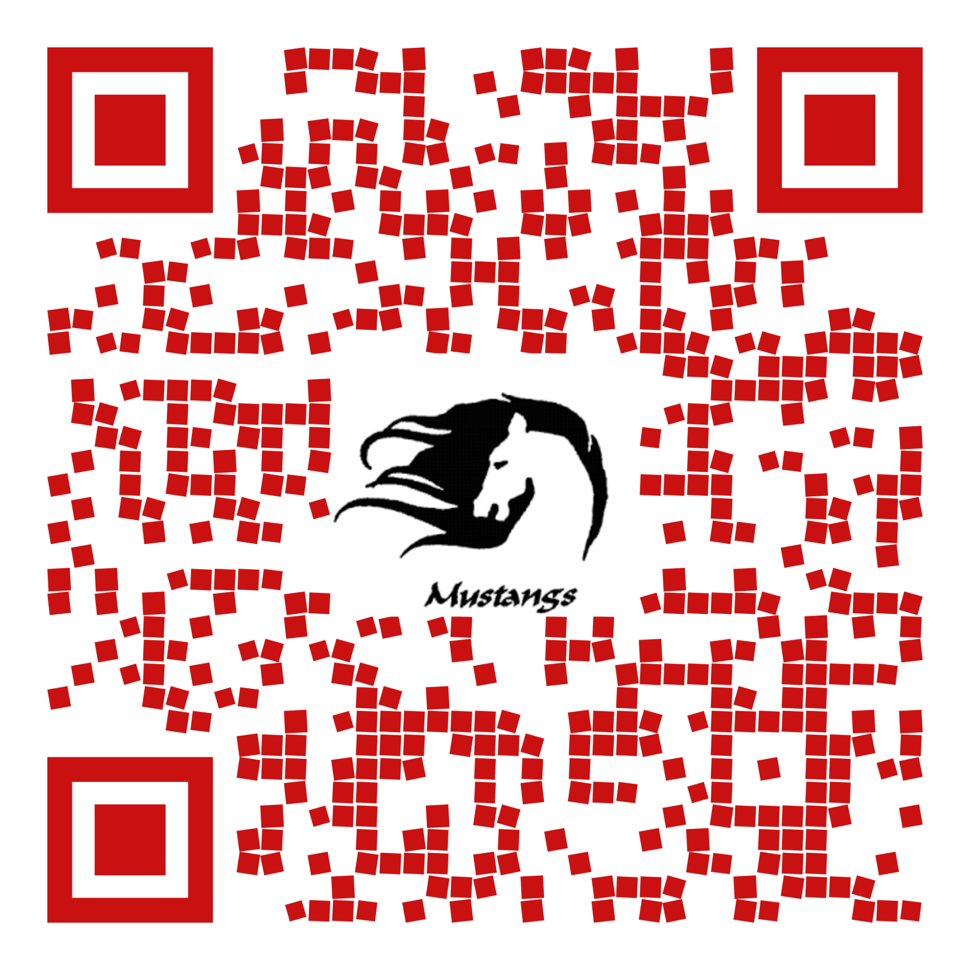
Counselor’s Corner
Hello, Centerville families! We are really enjoying this year and spending time connecting with and supporting our students! Your child can also use the QR code to the right to access our linktree and make an appointment with us.
The district invited families to join us virtually for a screening of the Screenagers movie, followed by a panel of district employees and a special guest from Common Sense Media. Ms. Grimmer and Ms. Glaze were part of the panel and shared about screen use (phones, social media, and video games) and how it impacts our students at CJHS. Here are some highlights from the video and the panel afterward:
- “Are you using your time wisely?” is a good check-in for phones. Kids need to practice using phones responsibly. Strong self-control is a better predictor of success, happiness, and healthy relationships than grades are. Self-control is a learned skill.
- There is a direct correlation between loss of empathy and too much screen time. Limiting screen time increases empathy.
Advice for parents:
- Define your parameters: where/when should you NOT use technology?
- Define your values: what do we care about as a family? How does technology help us achieve our values, and how does it detract from them?
- Understand how your child is accessing technology and what they are getting out of it.
- Practice with your child how to get out of a bad situation and how to pivot if a situation starts to feel bad or uncomfortable.
- As parents, where do we overprotect our kids? try to empower them to be able to respond in the moment.
Connect with us!
Please help us connect with your child by checking that they have joined our Counseling Google Classroom! We will post college and career information and class registration information throughout the year.
7th grade join code: qgfaeb6 8th grade join code: b5f5vxm

Beca Glaze (7th Grade) Imelda Garcia (8th Grade) Laura Schrenk (8/9 Transition) rglaze@fusdk12.net igarcia1@fusdk12.net lschrenk@fusdk12.net

