Unit: Badminton
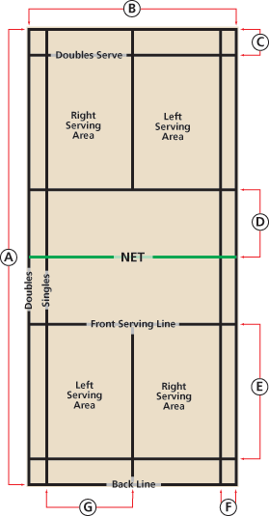
Basic Skills
1) Serving
2) Overhead Clear
3) Smash
4) Proper scoring
5) Positive sportsmanship/ team communication

Badminton Court Dimensions
The overall dimensions are 20 feet by 44 feet. The lines along these measurements mark the sidelines for doubles play and long service lines for singles play.
- The Net Line
The net line marks the middle of the court where the net is placed, creating a 22 feet by 20 feet area on each side of the net. The net- 5 feet tall in the center
- Short Service Line
6 feet 6 inches (some are marked 7 feet) from the center line. The area inside the short service line is also called the Non Volley Zone.
- Center Line
Divides the court from the Short Service Line to the Back Boundary Line. This delineates the Left from Right Service Court.
- Back Boundary Line
The same for singles/ doubles play it is the outermost back line on the court.
- Long Service Line for Doubles
2 1/2 feet inside the Back Boundary Line

Basic Game Rules:
- Badminton games are played to a score of 21. A game must be won by two points.
- Service must take place behind the service line and must be directed to the diagonal box.
- Doubles play uses the long-wide lines with the exception of the serve where the short back line is used.
- A shuttle that lands on a line is considered “in”.
- All serves must be contacted below the waist line.
- http://www.bwfbadminton.org/page.aspx?id=14914

Scoring:
DOUBLES:
- Serves are taken from the right side on a score of zero or an even number.
- Serves are taken from the left side on an odd score
- Only one person serves on the service team until the serve is lost.
- After a point has been scored, the service team rotates, the receiving team does not.
Assessment could be any combination of the following:
- Written test
- Visual observation of student game play( assessing student understanding of rules)

